Homepage

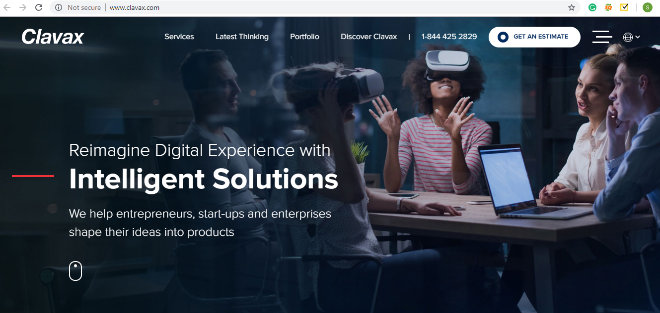

Source: <http://www.clavax.com/>

Tabs on Nunc: Expertise, Latest Thinking, Explore Nunc, Phone Number, Get an Estimate

Text to be used “**We owe our triumph to our dynamic culture that is rooted in self-organization.   
We are unique because we follow the customer-first approach**”

>> Next

Why Nunc >>in “**Place of We Are Clavaxians**”

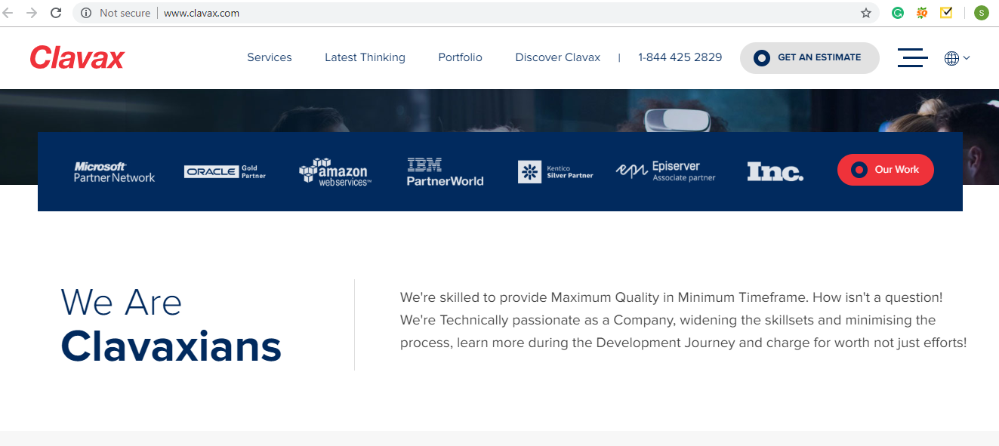

Text to be used:

NUNC Systems is an established Software development company that works with Enterprise systems and companies. As a privately-owned company, we provide IT Consultancy, Software Design, and Development as well as professional services and hardware deployment and maintenance to the various industries.

Over the years, we have emerged as a successful name in the global IT collaboration scenario. Though our roots are in India, we have a business presence in worldwide.

>> Next

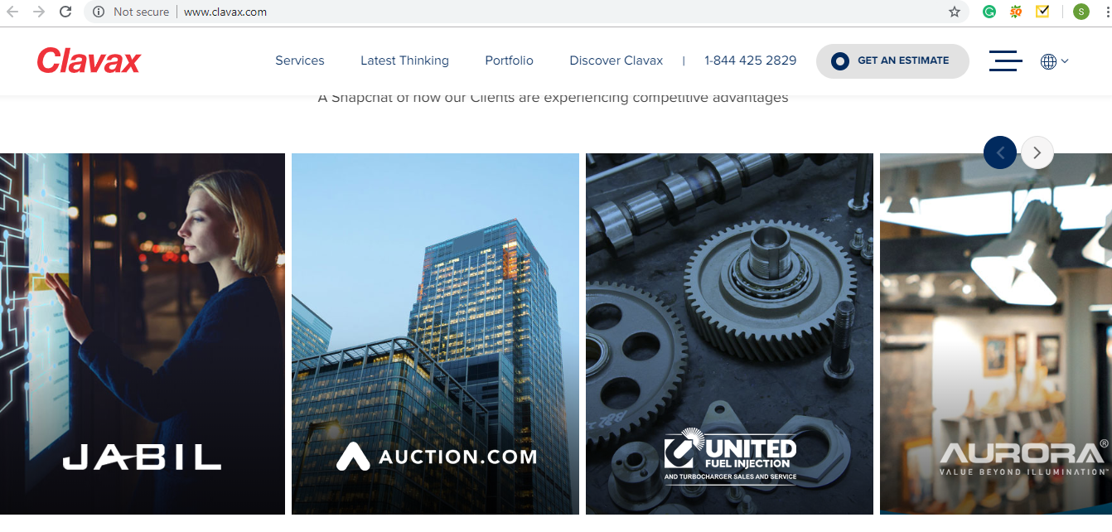

**Case Studies:** From our Existing website

**>> Latest Thinking**

Source: <https://www.unisys.com/>

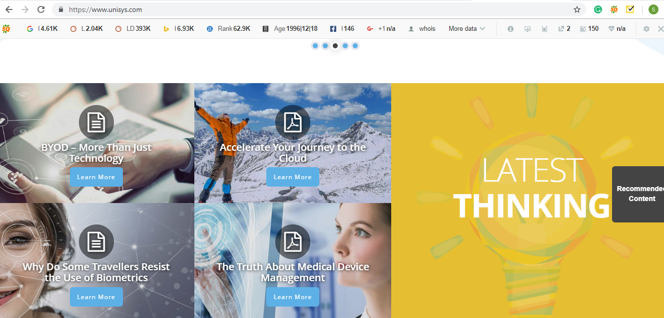

**Text to be Used:** Gain insights and foresights from various Industries, updates, top technology trends, implementation in Industries and a digital strategy that empowers your business to stay ahead of the competition.

>>

Next

**Client Testimonials**

Source: https://www.runzheimer.com/

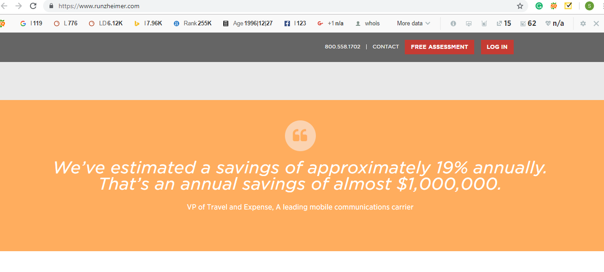

Since we have more than 1 testimonials we can have an auto slider here.

>> Next

Footer

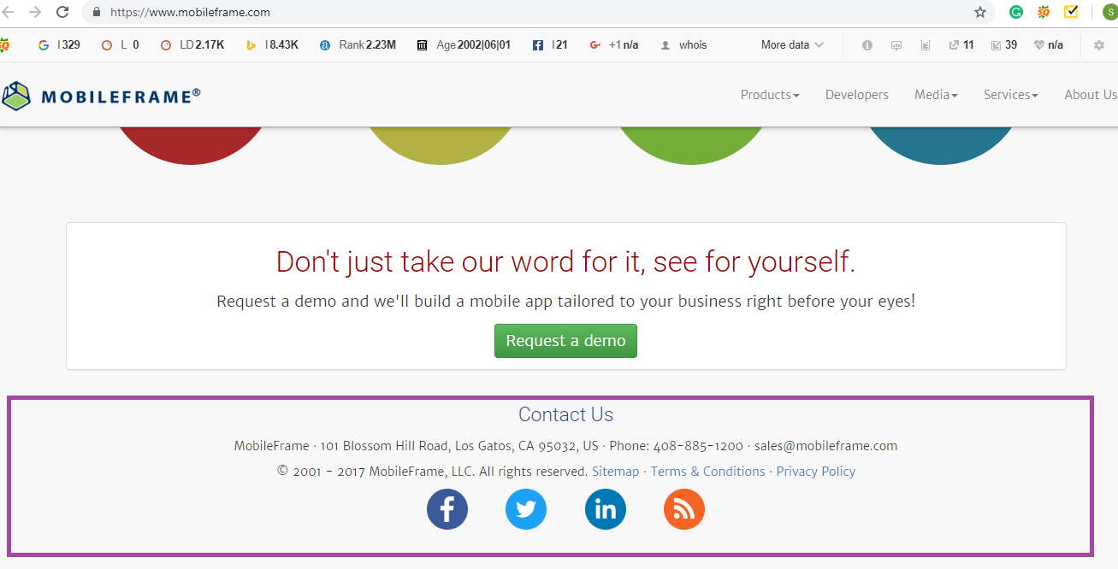

Source: <https://www.mobileframe.com/>

In the footer we even need to show the main links Such as Services, Industries and Product. It is a good practice from SEOs perspective.

This footer will be common for all the pages